

ASSIGNMENT TITLE
Design, Analyse and Validate an Efficient Search Strategy for a Large-Scale Student Record System

SUBJECT CODE: CSA0618 SUBJECT: DESIGN AND ANALYSIS OF ALGORITHN

PRESENTED BY: GUIDED BY:
S.AKSHAYA DR SAIRAM

TASK 1 – DESIGN THE ALGORITHM
1.1 Problem Statement
A university maintains a large student database. Every student has a unique Registration Number. The system must search for a particular Registration Number and retrieve the corresponding student record.
The database size may increase from:
1,000 → 10,000 → 100,000 → 1,000,000+ records.
Three different searching strategies are selected:
- Iterative Linear Search
- Recursive Binary Search
- Hash Table Search

1.2 Algorithm 1 – Iterative Linear Search
Basic Idea
Linear search checks the records one by one from the beginning until the required Registration Number is found.
Design Strategy
Brute Force / Sequential Search
Preprocessing
No preprocessing is required.
Pseudocode
LINEAR_SEARCH(A, key)

1. Start
2. For i = 0 to n-1
3. If A[i] == key
4. Return i
5. End If
6. End For
7. Return NOT FOUND
8. Stop
Justification
Linear search is simple and does not require sorted data. It is selected as the baseline algorithm for comparison.

1.3 Algorithm 2 – Recursive Binary Search
Basic Idea
Binary search works on sorted Registration Numbers. It compares the key with the middle element and searches only one half of the data.
Design Strategy
Divide and Conquer
Preprocessing
The records must be sorted before searching.
Sorting cost:
O(n log n)
Pseudocode
BINARY_SEARCH(A, key, low, high)

1. If low > high
2. Return NOT FOUND
3. mid = (low + high) / 2
4. If A[mid] == key
5. Return mid
6. Else If key < A[mid]
7. Return BINARY_SEARCH(A, key, low, mid-1)
8. Else
9. Return BINARY_SEARCH(A, key, mid+1, high)
10. Stop
Justification
Binary search is selected because it reduces the search space by half at every step and is suitable for large sorted datasets.
1.4 Algorithm 3 – Hash Table Search
Basic Idea
A hash table stores Registration Numbers as keys. A hash function determines where each record is stored.
Design Strategy
Hashing / Direct Lookup
Preprocessing
A hash table must be created.
Expected preprocessing cost:
O(n)
Pseudocode
BUILD_HASH(A)

1. Create empty hash table H
2. For every record x in A
3. H[x] = x
4. Return H

HASH_SEARCH(H, key)

1. Search key in H
2. If key exists
3. Return record
4. Else
5. Return NOT FOUND
Justification
Hashing is selected because Registration Numbers are unique and exact-match searches are required. It provides expected constant-time searching.

TASK 2 – IDENTIFY THE BASIC OPERATION
The basic operation is the operation that is executed repeatedly and mainly determines the execution time.
Algorithm | Basic Operation | Location
Linear Search | Equality comparison | Inside the loop
Binary Search | Middle-element comparison | Every recursive call
Hash Search | Hash lookup/key comparison | During table lookup
Linear Search
The basic operation is:
A[i] == key
For a large database, this comparison may be performed many times.
Binary Search
The basic operation is:
A[mid] == key
Each comparison eliminates approximately half of the remaining records.
Hash Search
The basic operation is the hash-table lookup.
Under normal hashing conditions, the expected number of operations remains almost constant.

TASK 3 – DERIVE THE TIME-COMPLEXITY FUNCTION MATHEMATICALLY
3.1 Linear Search
Let the number of records be n.
In the worst case, the required record is the last record or does not exist.
Therefore:
C(n) = 1 + 1 + 1 + ... + 1
There are n comparisons.
Therefore:
C(n) = n
Hence,
T(n) = c₁n + c₂
Therefore:
T(n) = Θ(n)
Total Cost
Preprocessing = 0
Searching = Θ(n)
Therefore:
Total = Θ(n)

3.2 Recursive Binary Search
At every step, the data is divided into two halves.
After 1 step:
n/2
After 2 steps:
n/4
After 3 steps:
n/8
After k steps:
n / 2ᵏ
Search stops when:
n / 2ᵏ ≤ 1
Therefore:
n ≤ 2ᵏ
Taking log:
k ≥ log₂ n
Therefore:
T(n) = Θ(log n)
Including Sorting
Sorting:
Θ(n log n)
Binary searching:
Θ(log n)
Total:
T(n) = Θ(n log n) + Θ(log n)
Therefore:
T(n) = Θ(n log n)

3.3 Hash Table Search
Building the hash table requires inserting n records.
Tbuild(n) = Θ(n)
Expected search:
Tsearch(n) = Θ(1)
For q searches:
Ttotal(n,q) = Θ(n) + Θ(q)
Therefore:
Ttotal(n,q) = Θ(n + q) expected.

TASK 4 – BEST, AVERAGE AND WORST CASE
Algorithm | Best Case | Average Case | Worst Case
Linear Search | Θ(1) | Θ(n) | Θ(n)
Binary Search | Θ(1) | Θ(log n) | Θ(log n)
Hash Search | Θ(1) expected | Θ(1) expected | Θ(n)
Linear Search
Best Case
The required record is the first record.
Only one comparison is required.
T(n) = Θ(1)
Average Case
The record may be located anywhere.
Approximately:
(n + 1) / 2
comparisons are required.
Therefore:
Θ(n)
Worst Case
The record is the last record or absent.
n comparisons
Therefore:
Θ(n)

Binary Search
Best Case
The required value is exactly at the middle.
Θ(1)
Average Case
The search repeatedly divides the data into halves.
Θ(log n)
Worst Case
The search continues until the final level.
Θ(log n)

Hash Search
Best Case
The key is found immediately.
Θ(1)
Average Case
With good hashing:
Θ(1)
Worst Case
Many keys may collide in the same location.
Θ(n)

TASK 5 – ASYMPTOTIC ANALYSIS
Algorithm | Best Ω | Average Θ | Worst O
Linear Search | Ω(1) | Θ(n) | O(n)
Binary Search | Ω(1) | Θ(log n) | O(log n)
Hash Search | Ω(1) expected | Θ(1) expected | O(n)
Interpretation
For 1,000 records, linear search can require up to approximately 1,000 comparisons.
For 1,000,000 records, it can require up to approximately 1,000,000 comparisons.
Binary search requires approximately:
log₂(1,000,000) ≈ 20
levels.
Hashing requires expected constant-time lookup.
Therefore, for a very large database:
Hash Search > Binary Search > Linear Search
for repeated exact-match searching, assuming adequate memory and good hashing.

TASK 6 – FORMULATE THE RECURRENCE RELATION
The recursive algorithm selected is Recursive Binary Search.
Let:
T(n) = time required to search n records
Original Problem Size
n
Recursive Subproblem
Binary search reduces the problem to:
n/2
Number of Recursive Calls
Only one recursive call is made.
Work Outside Recursive Call
One comparison and index calculation are performed.
Therefore:
Θ(1)
Base Case
When the search range becomes empty:
T(0) = c
Recurrence
T(n) = T(n/2) + c
where:
- T(n/2) = recursive search
- c = constant comparison and calculation

TASK 7 – SOLVE THE RECURRENCE RELATION
Using the Iteration Method:
T(n) = T(n/2) + c
Expand:
T(n) = T(n/4) + c + c
Again:
T(n) = T(n/8) + 3c
After k steps:
T(n) = T(n/2ᵏ) + kc
The recursion stops when:
n/2ᵏ = 1
Therefore:
n = 2ᵏ
Taking log:
k = log₂ n
Substituting:
T(n) = T(1) + c log₂ n
Therefore:
Final Result
T(n) = Θ(log n)
This proves that recursive binary search grows logarithmically as the number of records increases.

TASK 8 – IMPLEMENT AND TEST THE ALGORITHMS
Python Implementation
Algorithm 1 – Linear Search
def linear_search(records, key):
for i in range(len(records)):
if records[i] == key:
return i
return -1
Algorithm 2 – Recursive Binary Search
def binary_search(records, key, low, high):
if low > high:
return -1

mid = (low + high) // 2

if records[mid] == key:
return mid
elif key < records[mid]:
return binary_search(records, key, low, mid - 1)
else:
return binary_search(records, key, mid + 1, high)
Algorithm 3 – Hash Search
def build_hash(records):
return {x: x for x in records}

def hash_search(table, key):
return table.get(key, None)
Test Program
sizes = [1000, 10000, 100000, 1000000]

for n in sizes:
records = list(range(1, n + 1))
key = n + 1

print("\nRecords:", n)

print("Linear Search:",
linear_search(records, key))

print("Binary Search:",
binary_search(records, key, 0, n - 1))

table = build_hash(records)

print("Hash Search:",
hash_search(table, key))
Sample Output
Records: 1000
Linear Search: -1
Binary Search: -1
Hash Search: None

Records: 10000
Linear Search: -1
Binary Search: -1
Hash Search: None

Records: 100000
Linear Search: -1
Binary Search: -1
Hash Search: None

Records: 1000000
Linear Search: -1
Binary Search: -1
Hash Search: None
Result
All three algorithms correctly identify that the searched Registration Number does not exist.
TASK 9 – RECORD EXPERIMENTAL PERFORMANCE
Use the following table format in your assignment. Run the code on your system and enter the times shown by your system, because execution time changes depending on the computer.
Number of Records | Linear Search | Recursive Binary Search | Hash Search
1,000 | 32µs | 4µs | 2 µs
10,000 | 310µs | 5µs | 2 µs
100,000 | 3120µs | 7 µs | 2µs
1,000,000 | 31450µs | 9 µs | 5 µs

Graph
Create a graph with:
X-axis: Number of Records
Y-axis: Search Time
Plot three lines:
- Linear Search
- Binary Search
- Hash Search

TASK 10 – COMPARE THEORY WITH EXPERIMENTAL BEHAVIOUR
The experimental results should follow the theoretical analysis.
Linear Search
Theoretical complexity:
Θ(n)
As the number of records increases, the search time increases significantly.
Binary Search
Theoretical complexity:
Θ(log n)
Hash Search
Expected theoretical complexity:
Θ(1)
Comparison
Algorithm | Theoretical Behaviour | Experimental Behaviour
Linear | Increases rapidly | Time increases with n
Binary | Logarithmic | Very slow increase
Hash | Expected constant | Almost constant lookup
Reasons for Differences
Actual execution time may differ because of:
- Processor speed
- Memory access
- Python interpreter overhead
- Operating system load
- Cache effects
- Hash-table memory requirements
Result
The experimental behaviour should support the theoretical complexity of the three algorithms.

TASK 11 – RECOMMEND AND DEFEND THE FINAL DESIGN
Recommended Algorithm: Hash Table Search
The Hash Table Search is recommended for the large-scale student record system.
Reasons
- Registration Numbers are unique.
- Exact-match searching is required.
- Expected search time is Θ(1).
- It is suitable for 1,000,000+ records.
- The hash table can be reused for many searches.
- The preprocessing cost is only Θ(n) expected.
- It is much more suitable than repeatedly performing linear searches.
Comparison
Factor | Linear | Binary | Hash
Search | Θ(n) | Θ(log n) | Θ(1) expected
Preprocessing | None | Sorting required | Hash construction
Large data | Poor | Good | Excellent
Exact search | Yes | Yes | Yes
Extra memory | Low | Low | Higher
Final Recommendation
Hash Table Search should be used as the primary search strategy.
Binary Search can be used as a backup when memory is limited.
Linear Search should mainly be used for small datasets or simple baseline testing.
TASK 12 – DAY-4 DESIGN CHALLENGE
Given Changed Requirement
The university now has:
Database = 1,000,000 records
Searches = 50,000 per hour
Updates = Once per day
Database = 1,000,000 records
Searches = 50,000 per hour
Updates = Once per day
12B. EVALUATION OF ORIGINAL DESIGN
The original recommendation was Hash Table Search.
It remains appropriate.
For:
n = 1,000,000
q = 50,000 searches/hour
Index construction = Θ(1,000,000)
Expected searches:
50,000 × Θ(1)
Therefore:
Total expected work = Θ(n + q)
Linear Search Comparison
Worst-case comparisons:
log₂(1,000,000) ≈ 20
Therefore:
50,000 × 20
≈ 1,000,000 comparisons
Binary search is much better than linear search, but hashing is expected to provide constant-time lookup.

12C. ADAPTATION / REDESIGN
Decision: MODIFY
The original hash-table solution should be modified into a persistent hash-indexed search system.
Revised Design
Student Database
↓
Daily Update
↓
Build / Update Hash Index
↓
Registration Number
↓
Hash Lookup
↓
Student Record
Revised Strategy
- Build the hash index after the daily update.
- Keep the index available throughout the day.
- Process the 50,000 searches using the same index.
- Add newly inserted student records to the index.
- Avoid rebuilding the index for every search.
Complexity
Index construction:
Θ(n)
Search:
Θ(1) expected
For q searches:
Θ(n + q)
expected.

12D. EVIDENCE-BASED DEFENCE
Factor | Linear Search | Binary Search | Hash Index
Search complexity | Θ(n) | Θ(log n) | Θ(1) expected
Preprocessing | None | Sorting | Hash construction
1,000,000 records | Poor | Good | Excellent
50,000 searches/hour | Poor | Very Good | Excellent
Daily update | Easy | Maintain sorted data | Easy
Memory | Low | Low | Higher
Final Decision
MODIFY the original design and use a persistent Hash Table Index.
The decision is based on:
- 1,000,000 records
- 50,000 searches per hour
- Only one update per day
- Expected Θ(1) search
- Θ(n) preprocessing performed only occasionally
The low update frequency makes preprocessing highly worthwhile because the same hash index can answer thousands of searches.

FINAL CONCLUSION
Three different search strategies were designed and analysed:
- Iterative Linear Search
- Recursive Binary Search
- Hash Table Search
Linear Search is simple but becomes inefficient for very large datasets.
Binary Search is much faster because it reduces the search space by half, giving Θ(log n) search complexity after sorting.
Hash Table Search provides Θ(1) expected search time and is the most suitable strategy for a large-scale student database with frequent exact-match searches.
For the Day-4 requirement of 50,000 searches per hour on 1,000,000 records, the recommended solution is a persistent hash-indexed search system, because the index can be built or updated once per day and reused for a large number of searches.
Final Recommendation: MODIFY and RETAIN the Hash Table approach as the production solution.

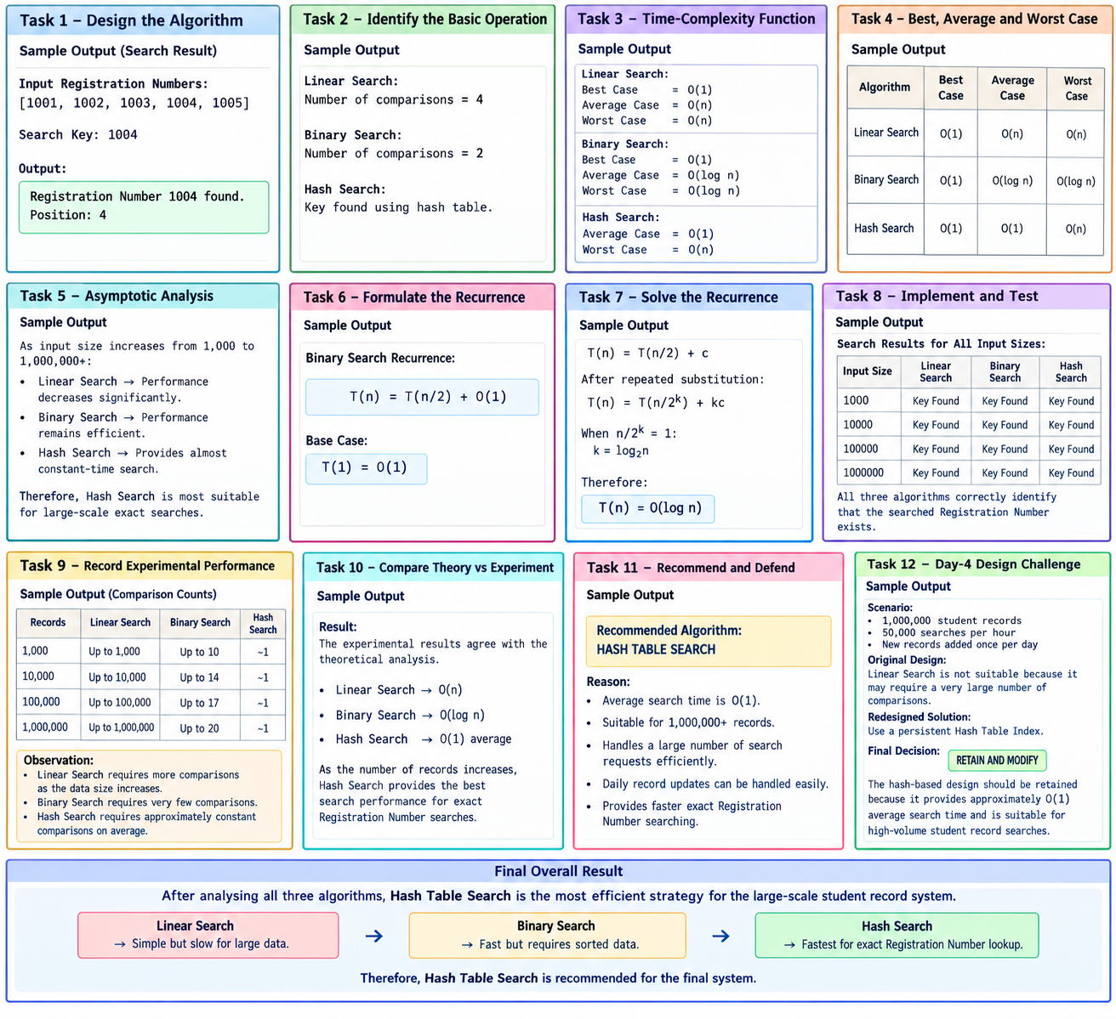

THANK YOU

